Front End Engineer Take-Home Test

Using JavaScript, DOM, and CSS, implement a dynamic menu system based upon the following design in **no more than 3 hours.** You may choose a 3 hour window of time that works best for you. When you are ready, e-mail your recruiting contact to announce that you are beginning the test:

C:\Users\deckel\Desktop\cursor.png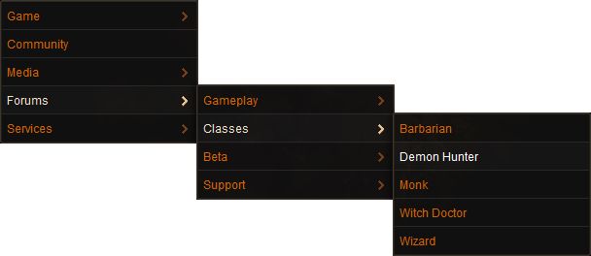

## Requirements

* Use a JSON object that represents the arbitrary depth menu structure.
* Use JavaScript to construct DOM nodes from the JSON data.
* Do not use any 3rd party libraries, such as jQuery or reset stylesheets. All markup and script must be written by yourself.
* The menu must work in the latest version of either Chrome or Firefox – pick one to develop with.
* You are free to use CSS, DOM, and JavaScript reference material, but do not reference code samples or other menu libraries.
* Emulate the design shown as closely as possible.

## Deliverables

No later than 3 hours after beginning work, a zip file containing all files necessary to demo your implementation of the above menu should be sent to the e-mail address(es) that you were provided.

**Good luck!**